shivaprasad sultan ravinder

msprasadreddy91@gmail.com

3DV Mapping

Map your way

Table of Contents

Creating a 3DV document 2

Adding an 3DVGIS Online base map into 3DVGlobe 2

Use portals in 3DVGIS Desktop applications 3

Download maps and layers 4

# Creating a 3DV document

You create a 3DV document by starting either 3DVGlobe or 3DVScene and then adding data. You can add surface data, image data, 2D or 3D feature classes, layer (.lyr) files, or copy and paste layers between 3DGIS applications.

Once you've added data to a 3D view, you can change how the layers are rendered by modifying their layer properties. The 3D properties you can set for a layer, such as those found on the Elevation (3DV) and Base Heights (3DVScene) tabs, do not apply in 3DVMap. Similarly, some symbology you can set in 3DVMap, such as multilayer symbols, will not show up in 3D. Features in 3D can be symbolized with simple 2D symbols or three-dimensional models.

3D documents can also have properties that affect the whole view, such as background display options, illumination, and vertical exaggeration.

# Adding an 3DVGIS Online base map into 3DVGlobe

Adding 3D base maps to your globe document is a breeze with 3DVGIS Online. You can choose from the key 3DVGIS Online base maps such as World Imagery, World Streets, and World Topographic Map, or opt for the Bing Maps services and many more. Seeing these base maps come to life requires an Internet connection, thus enabling you to add great-looking maps without quickly downloading or managing data locally. To top it off, the content found in these services is frequently updated.

**Note:** That none of the online base maps will work in 3DVScene.

To add an online base map in 3dvGlobe, do the following:

1. Click the Add Data drop-down arrow and click Add Base map.
2. The Add Base map window appears.
3. Select the base map and click Add.

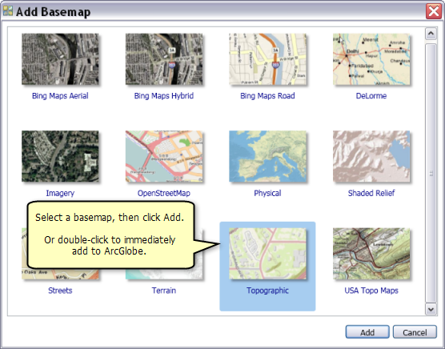

# Use portals in 3DVGIS Desktop applications

You can share maps and geographic information with others through 3DVGIS Online and 3DVGIS Enterprise, including maps, map layers, features, imagery, and analytic results. For example, you can publish your maps or layers as GIS web services, package the information into a single file containing all the necessary information and metadata, or load and share your packages using 3DVGIS Online or 3DVGIS Enterprise portals.

The following sections cover many common tasks used for sharing and exchanging maps, layers, and other geographic information using 3DVGIS Online.

You need 3DVGIS 9.3.1 or higher to use the Bing Maps base map services layer. This version is essential for the three Bing Maps service layers to function correctly. The Search control on the 3DVGIS.com website can also be used to find extra data that can be added to 3DVGlobe – provided 3DVMap is not running, as any content, you wish to add will go directly into 3DVMap if it's open.

If you'd like a deeper understanding of web maps and online GIS services, then look at the Mapping and Visualization chapter in our help section, which contains further information about these topics.

[Cite your source here.]

# Download maps and layers

When you add a map package or layer package from a portal to your 3DVGIS Desktop session, it will be downloaded and unpacked for use on your desktop. This content is saved in the Packages subfolder of your system's default 3DVGIS folder - <path>\My Documents\3DVGIS\Packages - with each package in its subfolder. The layers added to your map document will reference this location. Over time, the size of this directory can become quite large, so make sure to remove any unwanted packages and move their geodatabase contents into your working geodatabases if necessary.